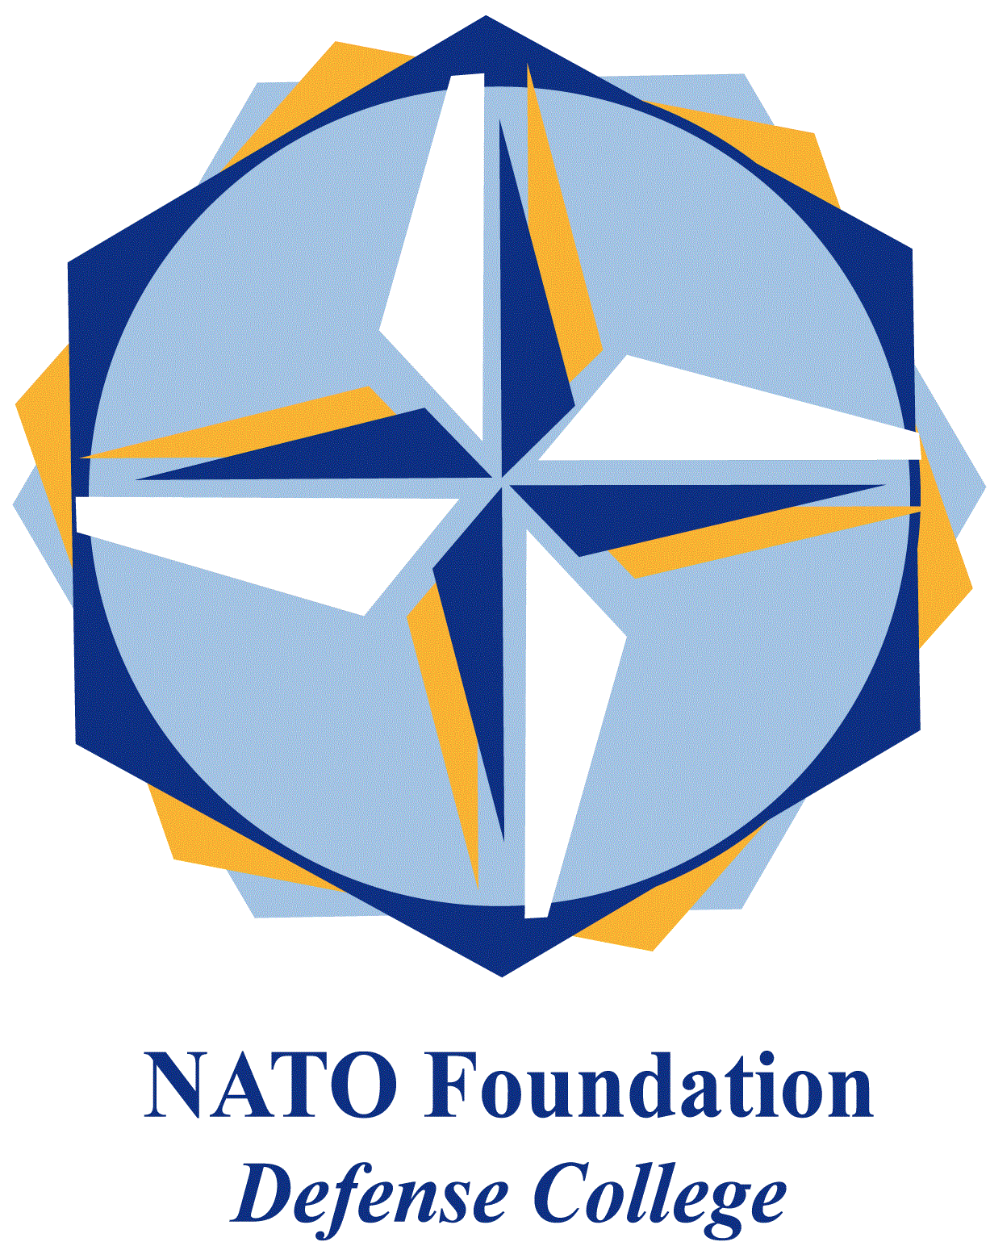
NATO DEFENSE COLLEGE FOUNDATION
STRATEGIC TRENDS
March 2016
LEVANT
Syria’s diplomatic front
This month marked important developments in the pro-Assad regime front of the Syrian civil war. One big twist took place on 14 March 2016 when Russian President Vladimir Putin ordered withdrawal of the “main part” of the Russian forces from the country, lowering the intensity of Russian military operations in Syria at December 2015 level.
Russian forces will be engaged in monitoring the respect of the US-Russia brokered ceasefire, which has been largely holding for more than a month, and they would still provide air cover and routine support to the government. As the ceasefire is not valid indeed for Daesh (al-Dawla al-Islamiya al-Iraq al-Sham - Islamic State of Iraq and the Levant), Assad has taken the opportunity to focus its efforts against it, recapturing, with Russian support, the city of Tadmur and the historic and highly symbolic site of Palmyra.
The Russian-Syrian choice to focus on the fight against Dawla (the State), and the recapture of Palmyra will undoubtedly bolster Bashar Assad’s credibility in the international arena and in the Geneva negotiations. Assad himself has recently declared that he expects military successes on the battlefield to speed up a political settlement as they show that the Russian-Syrian front is engaged in fighting terrorism. Indeed even UN chief Ban Ki Moon said that he was “encouraged” that Syrian troops retook Palmyra and, in general, since the rise of ISIS, and its attacks on European soil, the international community has started to soften its stances against gross human rights violations on part of the Syrian regime.
Other than some public relations campaign, a favourable strategic balance on the Syrian ground is going to help Assad’s cause in Geneva. The Russian military intervention turned out to be a game-changer in the Syrian Civil War: it stopped the bleeding of the Syrian army and allowed it to shift from defence to offence. In particular regime forces have advanced in northern Latakia, Aleppo, eastern Homs and, although in a more limited way, in Daraa. A very key frontline remains Aleppo, Syria's largest city and its main urban centre, that the regime has entered from south-east. Being located only 50 kilometres from Turkey, fully controlling Aleppo would mean also controlling the Turkish-Syrian border, the strongest rebels’ lifeline.
However Assad’s confidence in the odds that the regime’s stakes will prevail in Geneva will have to take into account the fact that both the main opposition body, the High Negotiations Committee (HNC) and the US, pushed by regional powers such as Turkey or Gulf Arab’s states, maintain that Assad must step aside as part of a political settlement, calling his participation in a transition process a “non-starter”.
Finally, the option of turning Syria into a federal state is also looming on the country’s future. Syria’s Kurds earlier this month declared a federal region across the numerous provinces they control, in the attempt of carving out an autonomous enclave on the blueprint of the Kurdistan Regional Government in Iraq. However, this move, broadly rejected by those negotiating in Geneva, including Damascus and UN’s Syria envoy Staffan de Mistura, risks further complicating the talks. Syria’s fragmentation into sectarian statelets might be the easiest way to accommodate the geopolitical interests of foreign powers but as the regional history has proved, fragmentation usually leads to further chaos.

